### Custom Collector: _Public_IP

1. Click MENU | CATALOG | COLLECTORS
2. Click +Add
3. Name: __Public_IP
4. Description: Gathers Public IP information using Webget from ipinfo.io
5. Windows Type: Execute PowerShell Script
6. Content:
   1. Copy content from the Display Network Interfaces collector on last page of this document
7. Collector Output: Add output from respective Custom Collector in the Appendix. The output of this collector includes public_IP, City, State, Country, Longitude, Latitiude, and ISP
8. Click Save

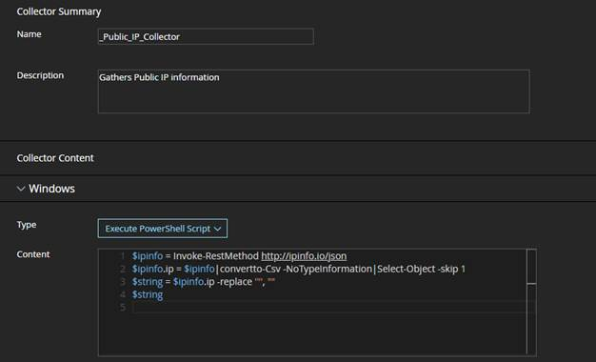

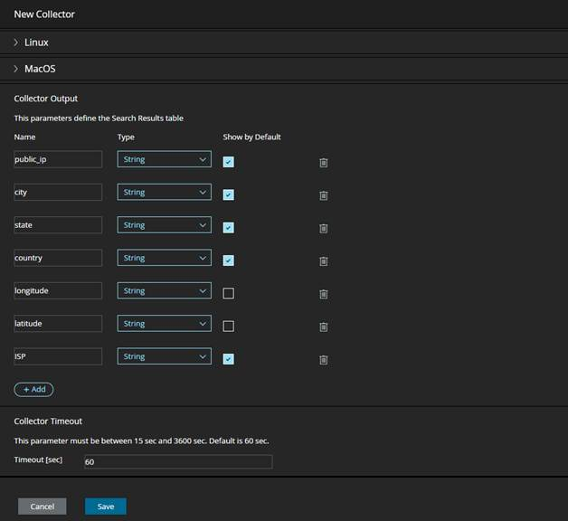

### ***Display Network Interfaces (PowerShell)***

Name: __Public_IP

Description: Gathers Public IP information using Webget from ipinfo.io

$ipinfo = Invoke-RestMethod http://ipinfo.io/json

$ipinfo.ip = $ipinfo|convertto-Csv -NoTypeInformation|Select-Object -skip 1

$string = $ipinfo.ip -replace '"', ""

$string

­­ Collector output should be:

* Name: public_IP, and, Type: IP, Default: Checked
* Name: City, Type: string, Default: Checked
* Name: State, Type: string, Default: Checked
* Name: Country, Type: string, Default: Checked
* Name: Longitude, Type: string, Default: UnChecked
* Name: Latitiude, Type: string, Default: UnChecked
* Name: ISP, Type: string, Default: Checked